Solution: using System;

namespace Abdul_wahab
{
class Program
{
static void Main(string[] args)
{
Console.WriteLine("Enter no of rows of Matrix 1"); int R1 = int.Parse(Console.ReadLine()); Console.WriteLine("Enter no of columns of Matrix 1"); int C1 = int.Parse(Console.ReadLine());
int[,] mat1 = new int[R1, C1];
Console.WriteLine("Enter elements of matrix 1 row by row"); for (int i = 0; i < R1; i++)
{
for (int j = 0; j < C1; j++)
{
mat1[i, j] = int.Parse(Console.ReadLine());
}
}
Console.WriteLine("Enter no of rows of Matrix 2"); int R2 = int.Parse(Console.ReadLine()); Console.WriteLine("Enter no of columns of Matrix 2"); int C2 = int.Parse(Console.ReadLine());
int[,] mat2 = new int[R2, C2];
Console.WriteLine("Enter elements of matrix 1 row by row"); for (int i = 0; i < R2; i++)
{
for (int j = 0; j < C2; j++)
{
mat2[i, j] = int.Parse(Console.ReadLine());
}
}

Console.WriteLine("Matrix 1 ="); for (int i = 0; i < R1; i++)
{
for (int j = 0; j < C1; j++)
{
Console.Write("{0,4}", mat1[i, j]);
}
Console.WriteLine();
}
Console.WriteLine("Matrix 2 ="); for (int i = 0; i < R2; i++)
{
for (int j = 0; j < C2; j++)
{

Console.Write("{0,4}", mat2[i, j]);
}
Console.WriteLine();
}
if (C1 == R2)
{
int[,] mat3 = new int[R1, C2]; for (int i = 0;

i < R1; i++)
{
for (int j = 0; j < C2; j++)
{
mat3[i, j] = 0;
for (int k = 0; k < C1; k++)

{
mat3[i, j] = mat3[i, j] + mat1[i, k] * mat2[k, j];
}
}
}
Console.WriteLine("Matrix 1 x Matrix 2 = "); for (int i = 0; i < R1; i++)
{
for (int j = 0; j < C2; j++)
{
Console.Write("{0,4}", mat3[i, j]);
}
Console.WriteLine();
}
}
else
{
Console.WriteLine("Multiplication is not possible");
}

}
}
}

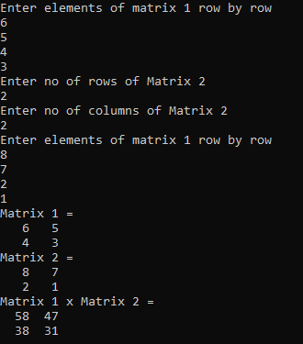

TASK 02: Take N number of user data input and make sure N is greater than 10, which contain name of the user, his/her nationality and his/her eye color. You have to show the max.
Solution:
using System;

namespace ConsoleApp44
{
class Program
{
static void Main(string[] args)
{
Console.WriteLine("Enter number of users");
int n = int.Parse(Console.ReadLine());
int C = 3;
string[,] a = new string[n, C];
a[0, 0] = "Name";
a[0, 1] = "Nationality";
a[0, 2] = "Eye Color";
int brown = 0, green = 0, black = 0, grey = 0, blue = 0;
for (int i = 0; i < n; i++)
{
for (int j = 0; j < C; j++)
{
if (i != 0 && j == 0)
{
Console.WriteLine("Enter Name {0}", i);
a[i, j] = Console.ReadLine();
}
if (i != 0 && j == 1)
{
Console.WriteLine("Enter Nationality {0}", i);
a[i, j] = Console.ReadLine();
}
if (i != 0 && j == 2)
{
Console.WriteLine("Enter EyeColor {0}", i);
a[i, j] = Console.ReadLine();
if (a[i, j] == "Brown" || a[i, j] == "brown")
{
brown++;
}
if (a[i, j] == "Green" || a[i, j] == "green")
{
green++;
}
if (a[i, j] == "Black" || a[i, j] == "black")
{
black++;
}
if (a[i, j] == "Grey" || a[i, j] == "grey")
{
grey++;
}
if (a[i, j] == "Blue" || a[i, j] == "blue")
{
blue++;
}

}
}
}

Console.Clear();
for (int i = 0; i < n; i++)
{
for (int j = 0; j < C; j++)
{
Console.Write("{0,16} ", a[i, j]);
}
Console.WriteLine();
}
Console.WriteLine("Total Brown eyes = {0}", brown);
Console.WriteLine("Total Green eyes = {0}", green);
Console.WriteLine("Total Black eyes = {0}", black);
Console.WriteLine("Total Grey eyes = {0}", grey);
Console.WriteLine("Total Blue eyes = {0}", blue);
}
}
}

Output:
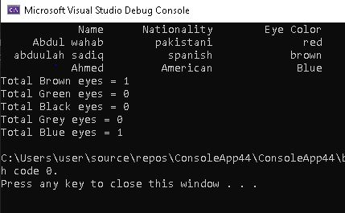
TASK 03:

using System;

namespace Abdul-wahab
{
class Program
{
static void Main(string[] args)
{
int n, total = 0;
double d = 1, dtotal = 0; Console.WriteLine("Enter No. of items:"); n = int.Parse(Console.ReadLine()); string[,] item = new string[n, 3];
for (int x = 0; x < n; x++)
{
Console.WriteLine("\nEnter name of item {0}:", x + 1); item[x, 0] = Console.ReadLine();
if (item[x, 0] == "rice" || item[x, 0] == "Rice")
{
d = 0.7;
}
Console.WriteLine("\nEnter price of {0} :", item[x, 0]); item[x, 1] = Console.ReadLine();
Console.WriteLine("\nEnter quantity of {0} :", item[x, 0]); item[x, 2] = Console.ReadLine();
total += (int.Parse(item[x, 1]) * int.Parse(item[x, 2]));
}

if (d != 0.7)
{
if (total >= 50000 & total <= 100000)
{
d = 0.8;
}
else if (total > 100000)
{
d = 0.7;
}
}

dtotal = total * d;
Console.WriteLine("S.no\t\tItem name\tPrice\t\tQuantity\n"); for (int x = 0; x < n; x++)
{

Console.Write("{0}", x + 1); for (int y = 0; y < 3; y++)
{
if (y == 1)
{

}
else
{

}
}
Console.Write("\t\t${0}", item[x, y]);

Console.Write("\t\t" + item[x, y]);

Console.WriteLine();
}
Console.WriteLine("\n\tTotal : {0:c}", total); if (d != 1)
{
Console.WriteLine("\n\tTotal after discount of {0:0.00}% is : {1:c}", (1 - d) * 100, dtotal);
}
}
}
}

OUTPUT::
